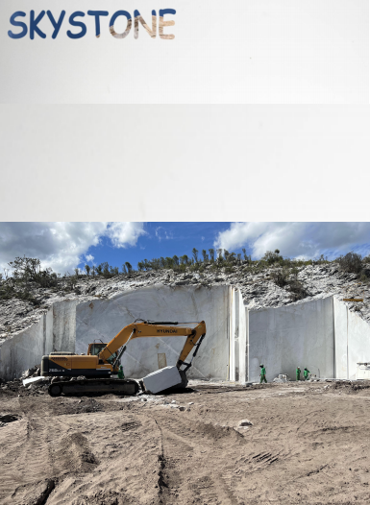

LOW AIR PRESSURE DTH
DRILL BIT. 低风压钻头
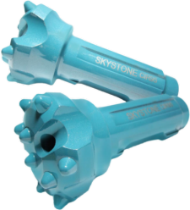

HIGH ABRASIVE
高磨蚀性
Double Gauge Face
边台阶型 Step Gau
凸面型
Convex Face
凹面型
Concave Face
0
中心下陷型
Drop Center Bit
很硬
VERY HARD

BIT FACE SHAPE SELECTION
钻头头部形状选择

BIT FACE SHAPE SELECTION
钻头头部形状选择

Drop Center Bit 中心下陷型
采用低-中风压钻凿软-中硬以及有裂缝的岩层时，为了获得更快的凿岩速度和较少炮孔的偏斜率，通常采用这种头部形状。
For high penetration rates in soft to medium hard and fissured rock formations.Low to medium air pressures. Maximum hole
deviation control.

Concave Face 凹面型
这种头部形状适用于所有岩层，特别是在中硬和岩性均匀的岩层中使用效果最好。炮仗偏离角度小。排渣效果好。
The all-round application bit face specifically for medium hard and homogenerous rock formations. Good hole deviation control
and good Flushing capacity.

Convex Face 凸面型
这种形状适用于低-中风压时候钻凿软-中硬岩层，钻头钢体不易腐蚀，其特点是边齿承载较低，磨损不严重，钻岩速度快，但炮孔偏差难以控制。
For high penetration rates in soft tomedium-hard with low to medium air pressures.It isthe most resistance to steel wash. And may
reduce the Load and wear on the gauge buttons，but poor hole Deviation control.

Double Gauge Face 双边齿型
这种双边齿形头部适用于高风压时钻凿很坚硬的岩层。此时钻速快，钻头磨损不严重。
This kind of face shape issuitable for fast penetration rates in medium to hardrock formations.Designed for high air pressures andGood resistance to steel wash step gauge bit.
Flat Face Bit 平面型
这种平面型头部适用于高风压时钻凿坚硬岩层以及腐蚀性强的岩层。此时，钻速较快，钻头磨蚀较少。
This kind of face shape is suitable for hardto very hard and abrasive rock formations inApplications With high air pressures.Good penetration Rates an resistance to steel wash.

岩石磨蚀性
ROCK ABRASIVENESS
平面型 Flat Face

双边齿型

SOFT 软岩
无磨蚀性
NON ABRASIVE

CARBIDE BUTTON SHAPE SELECTION
硬质合金齿形选择

Domed/Round Button 球齿
主要用作潜孔钻头边齿，适用于磨蚀性强非常坚硬的岩石。
Domed/Round Button are usually used as gaugebuttons of DTH Bits,suitable for very abrasive and very hard formations.
Parabolic Button 抛物线齿
主要用作潜孔钻头边齿和中齿，磨蚀性中等，比较硬的岩石。
Parabolic Button are usually used as gauge buttonsand front buttons of DTH Bits,suitable for medium abrasive and hard formations.
Ballistic Button 弹头齿
主要用作潜孔钻头的中齿，适用于磨蚀性中等，硬度中等的岩石。岩石比较软的情况下也可以做边齿。
Ballistic Buttons are usually used as front button of DTH Bits, suitable for medium abrasive and mediumhard formations. They can also be used as gaugeButtons if the rock is soft.
Sharp Button 尖齿
主要用作潜孔钻头的中齿，适用于高钻速，低断齿率的软岩层。
sharp Buttons are usually used as front buttons of DTH Bits for soft formations where fast penetration rates are possible and button breakage is minimal.
Flat Button 平头齿
主要用作潜孔钻头的中齿，减小钻头体表面的磨损。
Flat buttons are usually used as protection buttons reduce wear on rubbing surfaces of DTH Bits.

ISO9001 ：201 5

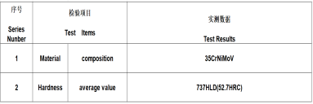
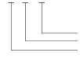
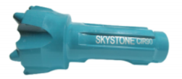
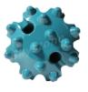
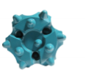
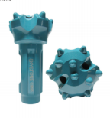
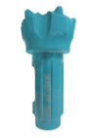
Product technical parameters 产品技术参数

LOW AIR PRESSURE DTH DRILL BIT
低风压潜孔钻头

Description of the model 型号说明
CIR90 - 95MM- CONVEX

齿形The shape of button
钎头直径 Bit diameter
连接规格 Connection

3" DTH drill bit 3英寸潜孔钻头
合金齿数量×直径
NO.Button size
产品型号  Model | 钻头直径  Bit Dia.(mm) | Front button | Gauge button | 连接规格  Connection | 边齿角度  Gauge tooth angle
CIR90-90MM-CONVEX | 90 | 2×13 / 2×14 | 6x14 | CIR90 | 45。
CIR90-95MM-CONVEX | 90 | 2×13 / 2×14 | 6x14 | CIR90 | 45。
CIR90-90MM-CONCAVE | 90 | 3×12 / 2×14 | 6x14 | CIR90 | 45。
CIR90-95MM-CONCAVE | 90 | 4×12 / 3×14 | 6x14 | CIR90 | 45。
BR3-95MM-CONVEX | 90 | 4×12 / 3×14 | 6x14 | BR3 | 45。
BR3-95MM-CONCAVE | 90 | 4×12 / 3×14 | 6x14 | BR3 | 45。

THANK YOU
FOR CHOOSING SKYSTONE

TECHNICAL
SUPPORT 技术支持

Bit Wear Patterns 钻头磨损模式

Gauge Wear 外圈磨损
In some materials such as hard sand stone and quartzite,the wear tends to be greater on the bit circumference.Most of the wear is on the outside buttons on the periphery,creating a tendency for bits to roundoff on the circumference.Thus,when the buttons are sharpened,the diameter across the gauge buttons will be less have to be ground down to restore adequate clearance and avoid this binding in the holes.The bit face will also,most likely,require grinding to restore button protrusion.
遇到硬质砂岩和石英岩等岩层时，钻头外围的磨损趋于增大。大部分磨损都位于边齿外侧， 使得钻头因外围磨损而作废。因此，合金齿修磨后，边齿构成的钻头直径会小于钻头肩部构 成的直径，钻头容易陷于孔眼中。钻头的肩部外围需要被修磨下去释放出足够的间隙以避免 钻头陷于孔眼。钻头面部也可能很需要修磨，从而重新突出合金齿。

Body Wash 裤体冲洗
When drilling in non-abrasive materials,where carbide wear is minimal,extended drilling intervals are possible.This allows for prolonged chip removal around the bits and will wear away the bit body to a greater extent than the buttons.Similar wear occurs in fractured and loose materials where excessive agitation and grinding of the materials is required for hole cleaning and to keep the hole open;during retraction .To prevent tearing out buttons and button shear under these conditions,the protrusion should be reduced by scheduling grinding intervals to grind down the buttons.
钻进非磨蚀性岩层时，合金齿磨损程度最小，可以延长钻进中的修磨间隔。这延长了钻头周 围岩渣排出时间，对钻头裤体被磨损会比合金齿大。类似的磨损情况也发生在断裂岩层和松 散岩层当中，有必要对岩渣过渡搅动和研磨清洁孔眼，以确保钻具回抽时孔眼不堵塞。为避 免钻头在这种情况下出现掉齿或断齿，突出的合金齿需要定期间隔地被修磨下去。

Excessive drilling 过度钻进
The detrimental effects of over drilling bits may not be immediately apparent.However,an often neglected reality is that running dull bits not only slows down the dilling rates but escalated diling costs by reducing life on the dilling tool components,the rock drills and the drill rig components.Over drlling is also unquestionably responsible for over 90% of all premature button failures.It is a well- documented fact that premature button bit insert failures are reduced substantially when over dilling is eliminated and proper sharpening is performed.
过度钻进造成的危害或许不会立即显示。然而一个常被忽视的现实就是使用钝掉了的钻头不 仅会减缓钻进速度，而且还减低钻具构件，凿岩机和钻机部件的使用寿命从而增加了钻进成 本 。90%的钻头合金齿提前失效情况都毫无疑问归结于过度钻进 。一个证据确凿的事实就 是当杜绝使用过度钻进的钻头并适当对钻头进行修磨后，柱齿钻头合金齿早期失效的情况会 大幅度减少。

Drill string Service life 钻具使用寿命

如果依照正确钻杆旋转指南操作，钻杆的使用寿命等于钻孔数乘以钻杆长度。
If following proper drill steel rotation guidelines,the life of a drill steel is equal to the number of holes drilled multiply the drill steel length.
钻杆寿命=钻孔数量×钻杆长度
岩层条件Rock conditions

容易 | 一般 | 困难
Favorable | Normal | Rough
600 | 300 | 150

以钻孔数衡量的寿命Service life in No.of holes
当使用多根钻杆组合钻进深孔时，下面的公式可以用来计算钻杆的平均寿命。
When dilling deep holes with multiple drill steels,the following formula can be used to calculate average drill steel life.

Rod feet  Hole feet | = | N(L+D)  2D
D=孔深hole depth L=钻杆长度Rod length
N=钻具上使用的钻杆数量Number of Rods in String
钻杆总长=孔深XK
Rod Feet=Hole depthXK K=(D+1)/2

Coupling Service life 连接套使用寿命
The coupling service life is equal to single thread drill steel.
连接套使用寿命等同于单根螺纹钻杆的使用寿命。

Shank adapter Service life 钎尾使用寿命
A shank adapters service life is between 915-1524m(3000-5000ft)
钎尾使用寿命范围在915米到1524米(3000-5000英尺)之间。

